# CS 255 System Design Document Template

## UML Diagrams

*

### UML Activity Diagrams

### UML Sequence Diagram

### UML Class Diagram

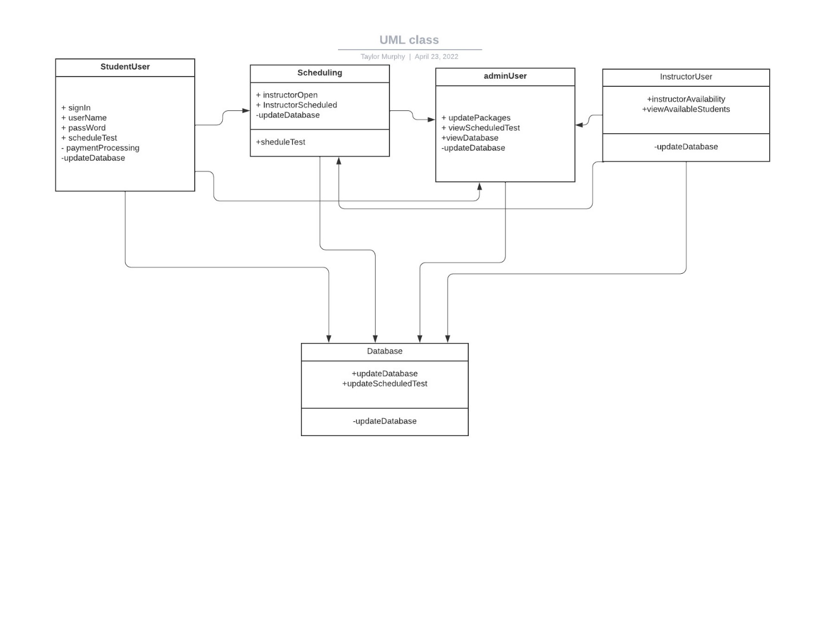

## Technical Requirements

* The users would need an internet connection.
* The required hardware should be a server capable of handling the user traffic and usage.
* This will be a cloud based system so a subscription or availability of a cloud service is required.
* The software would be a database software.
* There would need to be an infrastructure of a team that can update packages and maintain the system.
* There would also need to be a section of the team to maintain the databases.
* The databases would contain user information, scheduled tests, and student/instructor availability.